

LINEAR ALGEBRA (23MAT117)

LAB MANUAL

|  |  |
| --- | --- |
| **Submitted by** | |
| Name | G.L.KARTHIKEYA |
| Roll No | AV.SC.U4CSE24049 |
| Year/Sem/Section | 1st Year/2nd Sem/CSE-A |
| Date of Submission |  |
| **Submitted to** | |
| Name | Dr. Rashmi Prasad |
| Department | Mathematics |
| Designation | Professor |

Marks

1. Write a MATLAB code to define and display vectors.

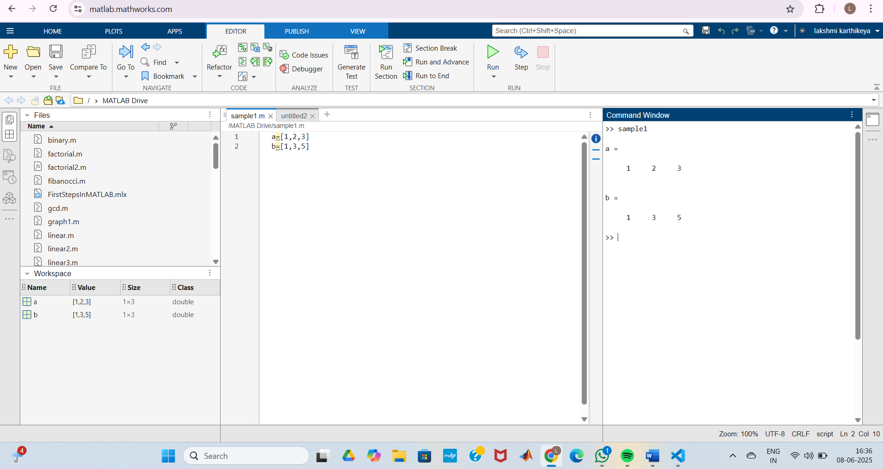

1. Write a MATLAB code to define and display matrix.

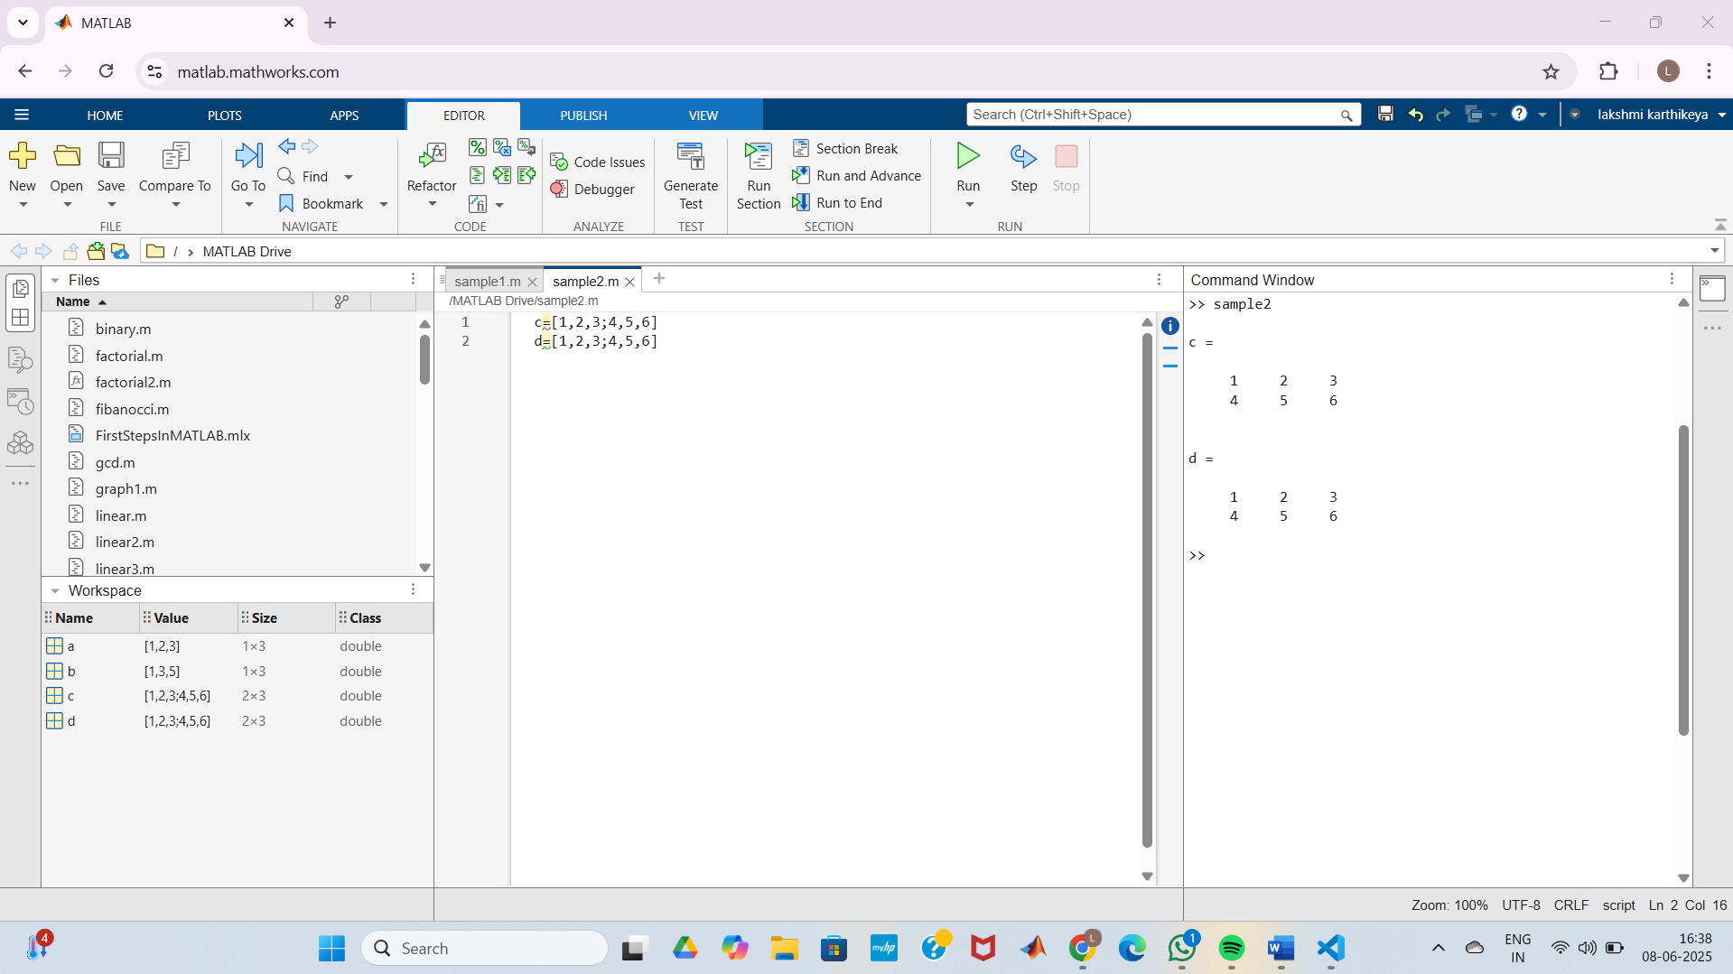

1. Write a MATLAB code to define and display a random matrix and their operations.

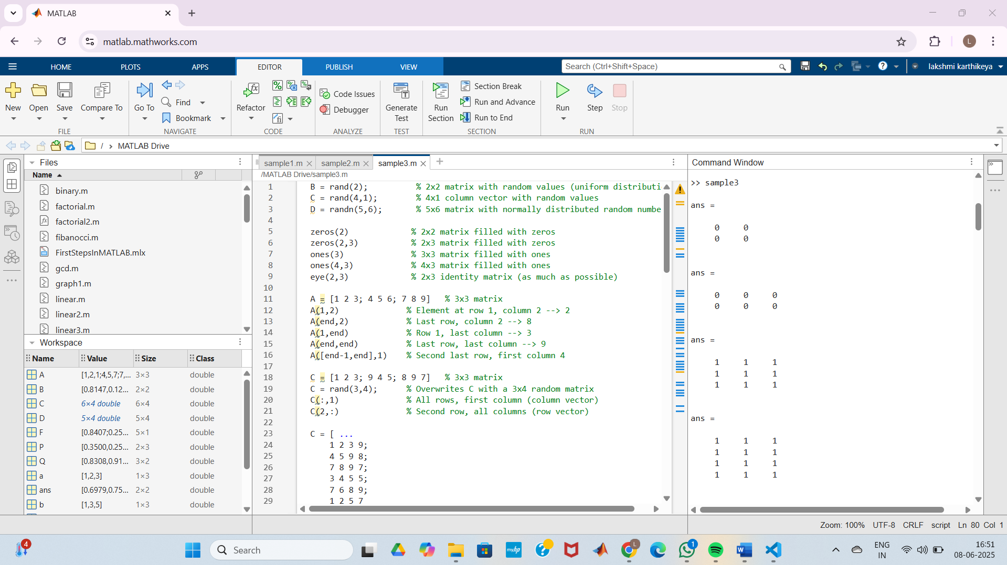

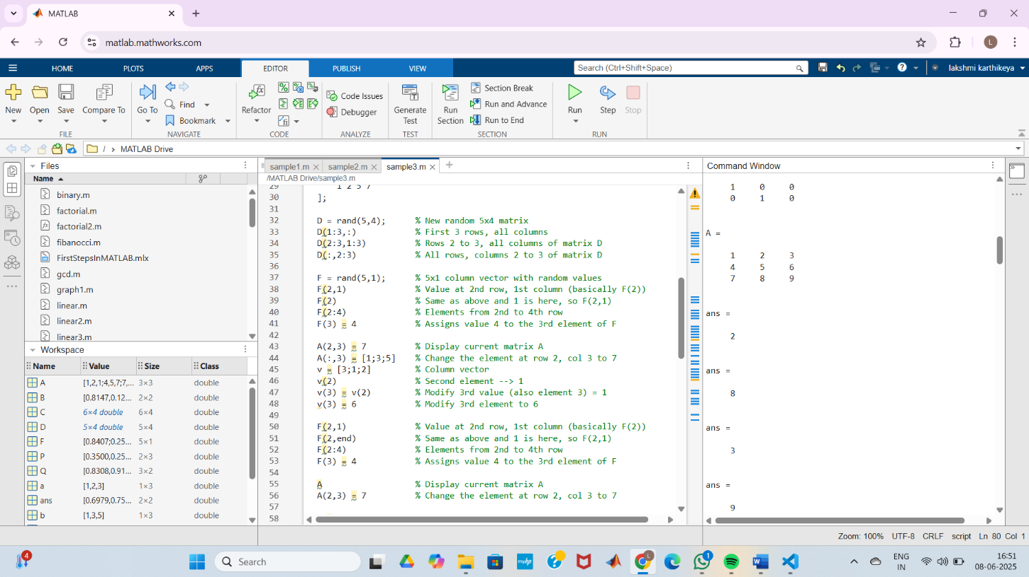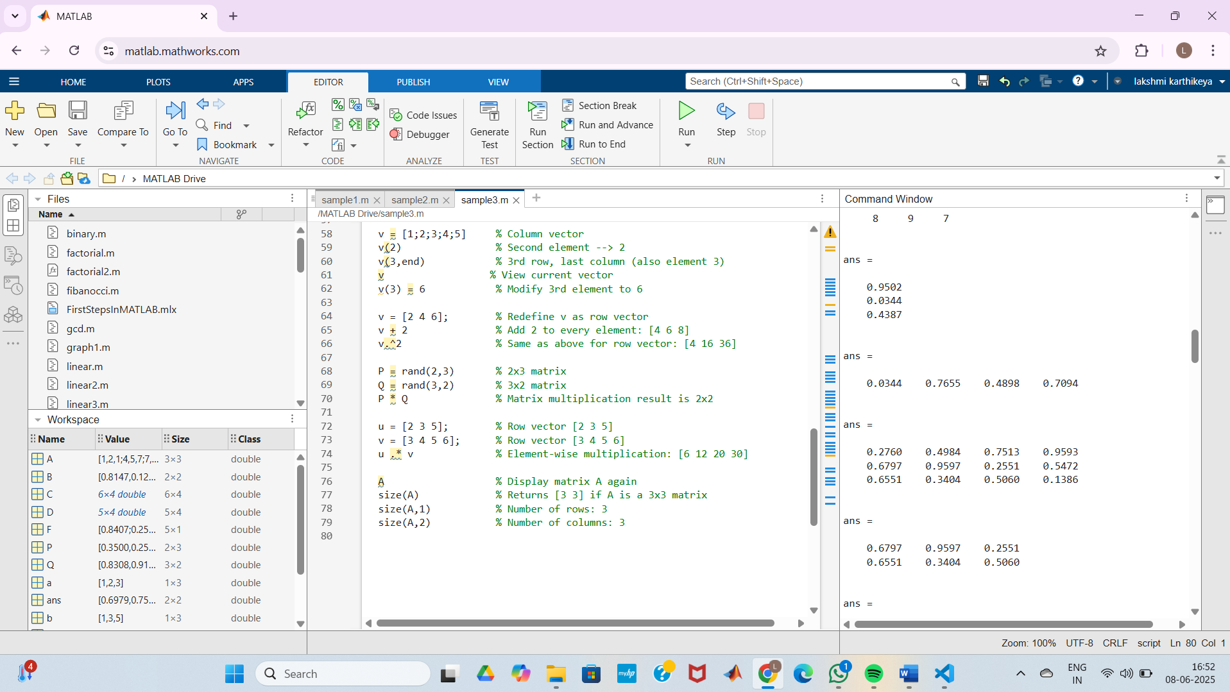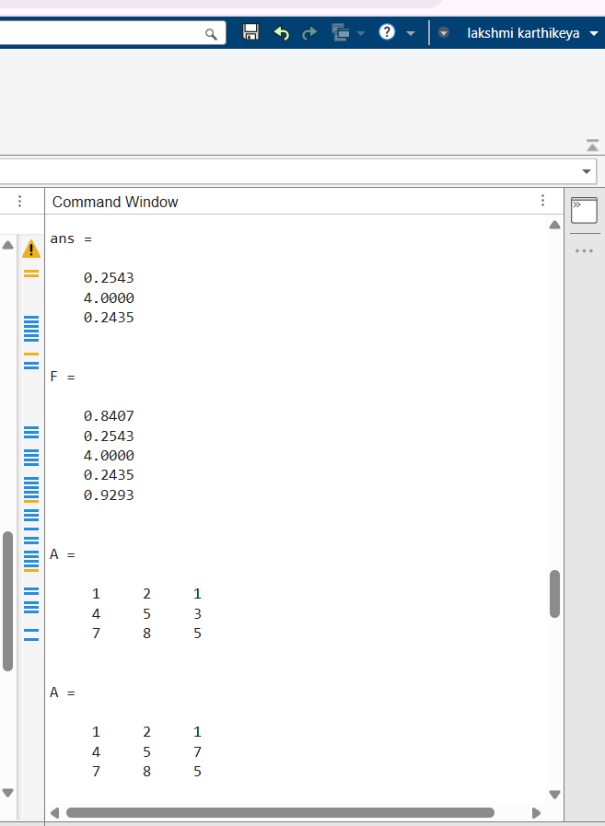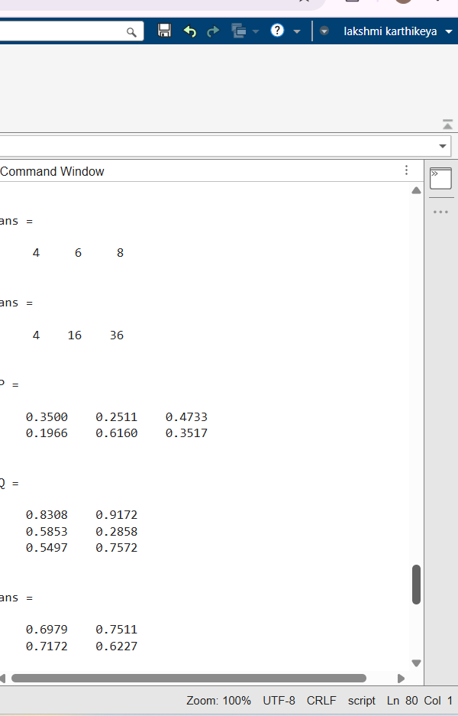

1. Write a MATLAB code to find the solutions of given linear system of equations.

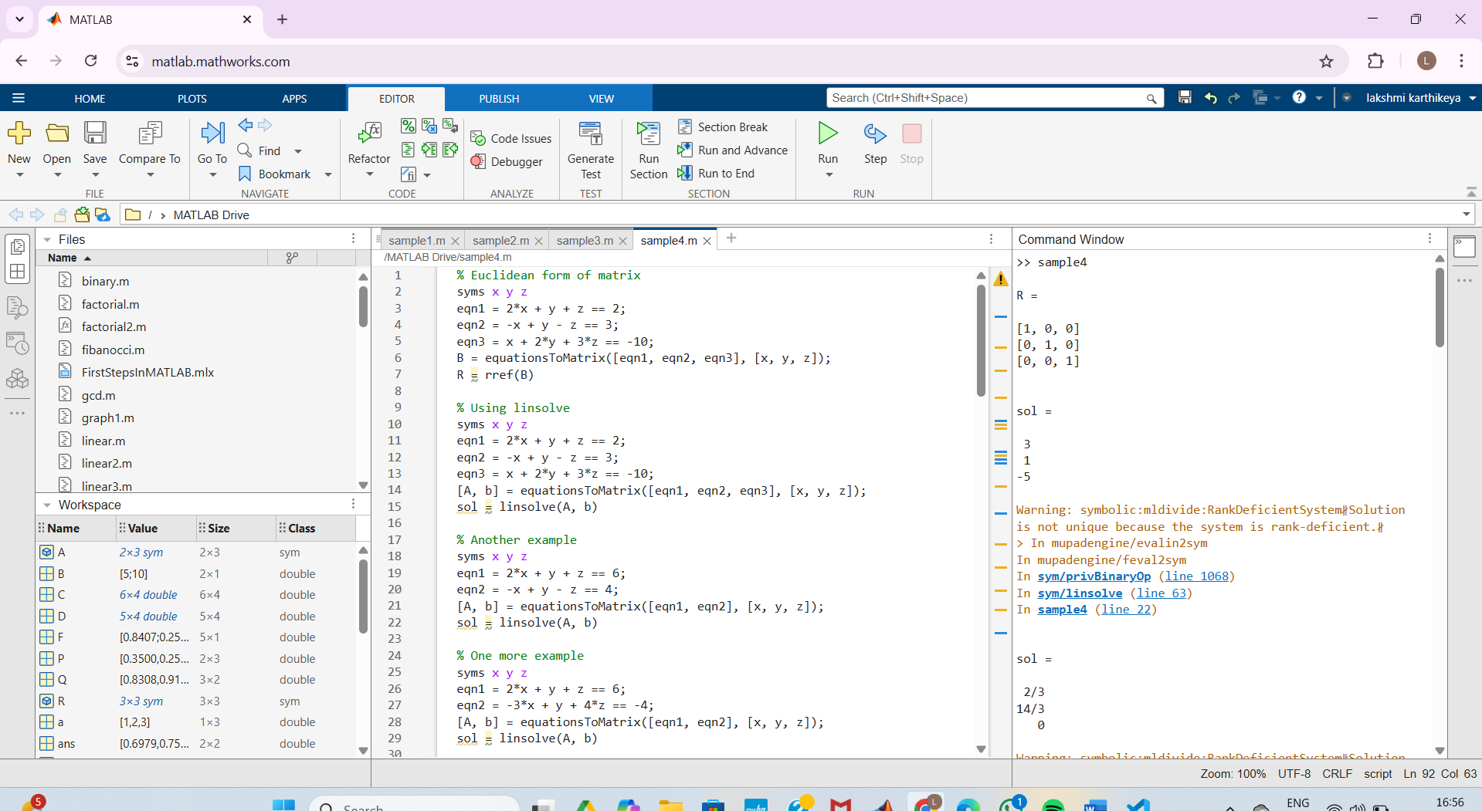

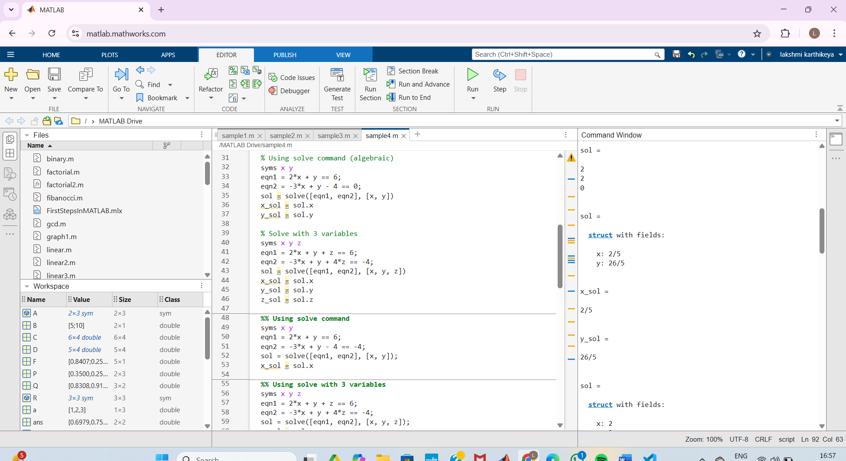

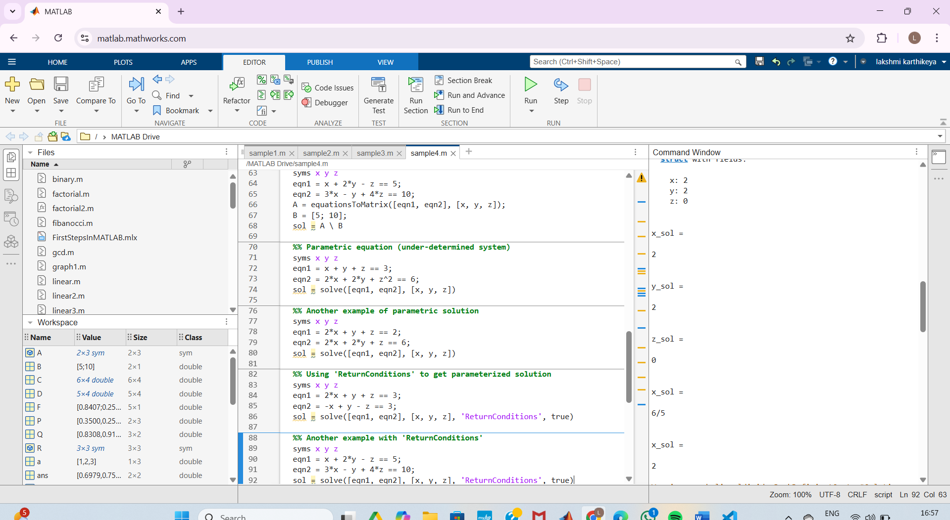

1. Write a MATLAB code to draw the vectors (3,4) and(-2,5) in a 2-D plane.

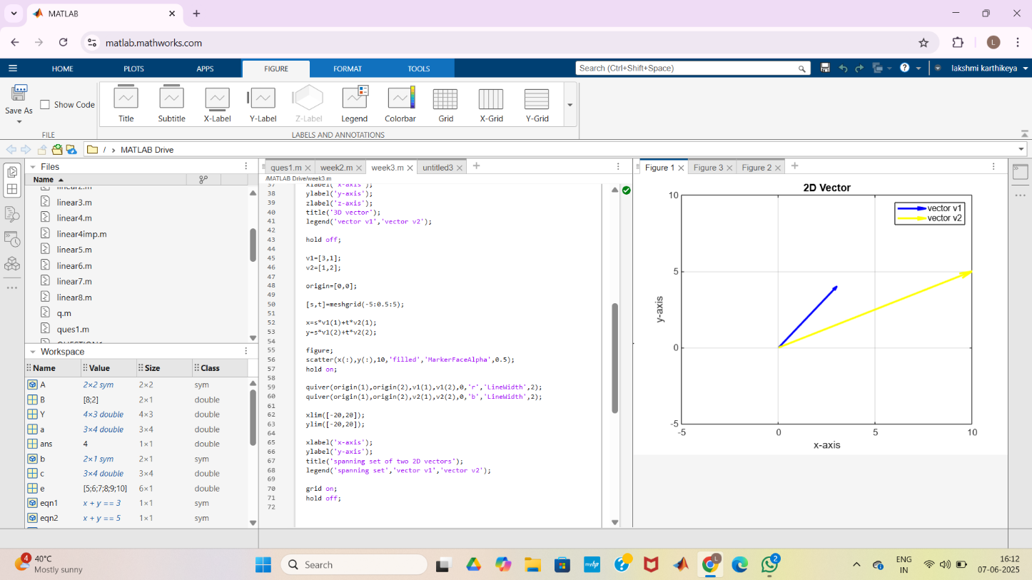

1. Write a MATLAB code to draw the vectors (3,4) and(-2,5) in a 3-D plane.

Using MATLAB, define the vectors v1 = [3, 1] and v2 = [1, 2]. Write a program to visualize their span in 2D space.

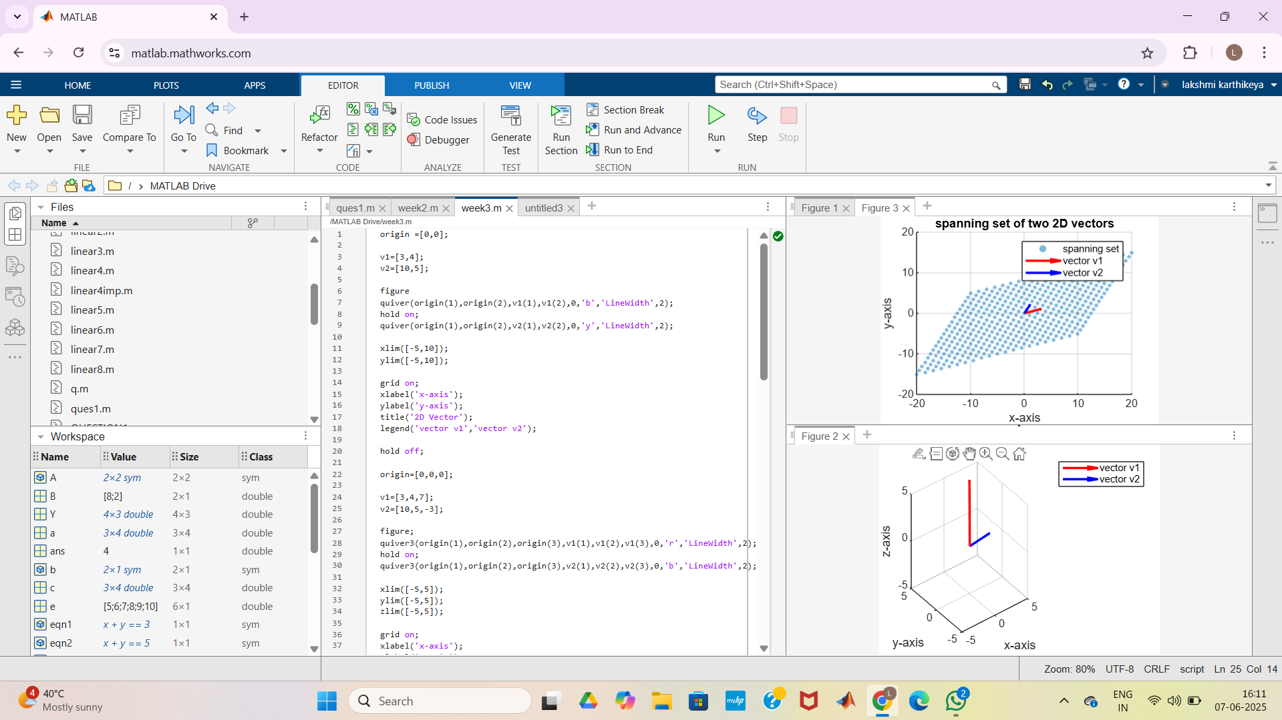

Using MATLAB, for any given positive integer and for any given basis for Rn. write a program to find the orthonormal basis corresponding to the given basis.



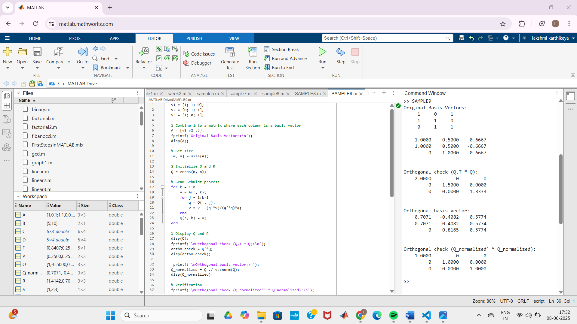

1. Using MATLAB, write a program to find the QR decomposition corresponding to the give

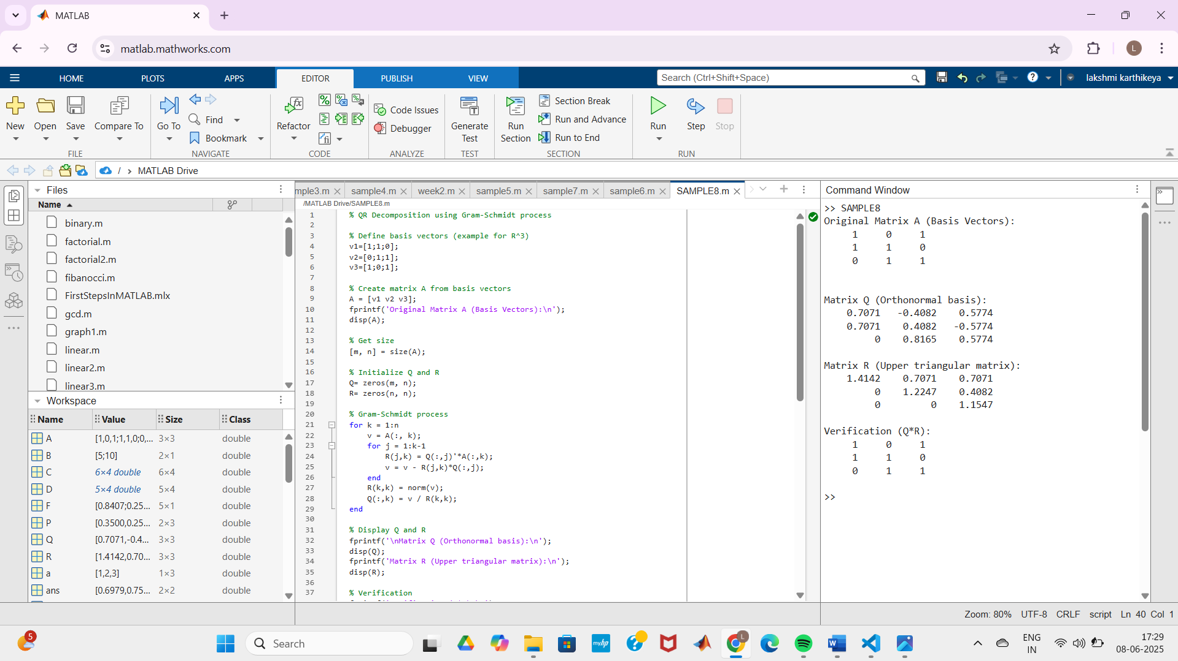

1. Using MATLAB, write a program to Visualize how a matrix transforms the unit circle.

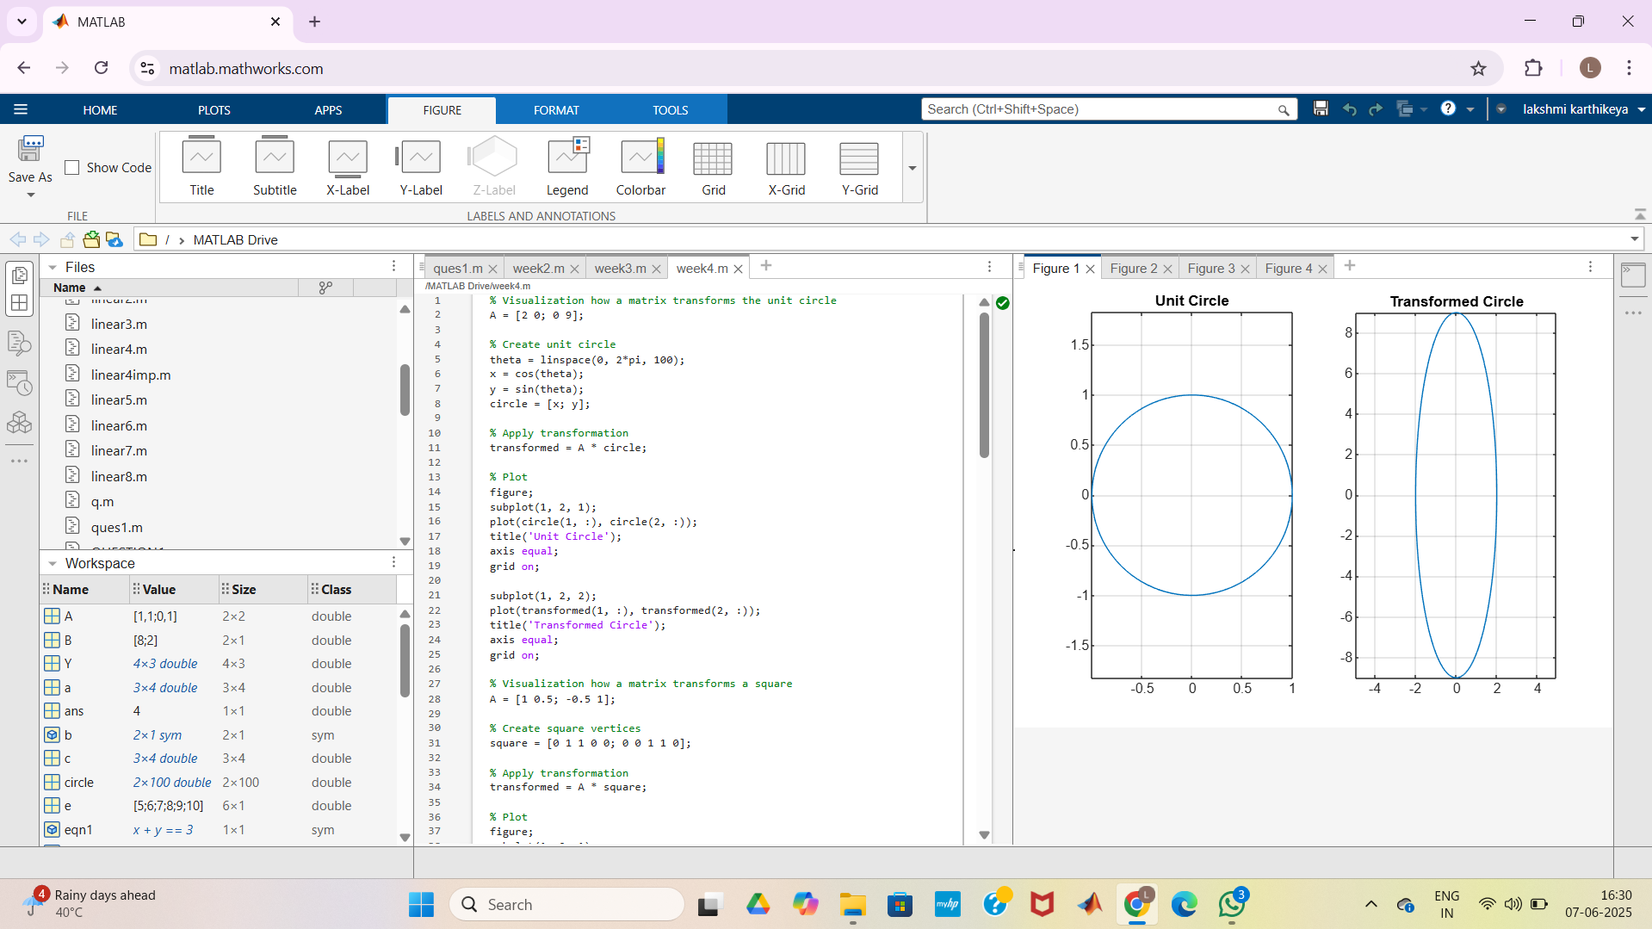

1. Using MATLAB, write a program to Visualize how a matrix transforms a square.

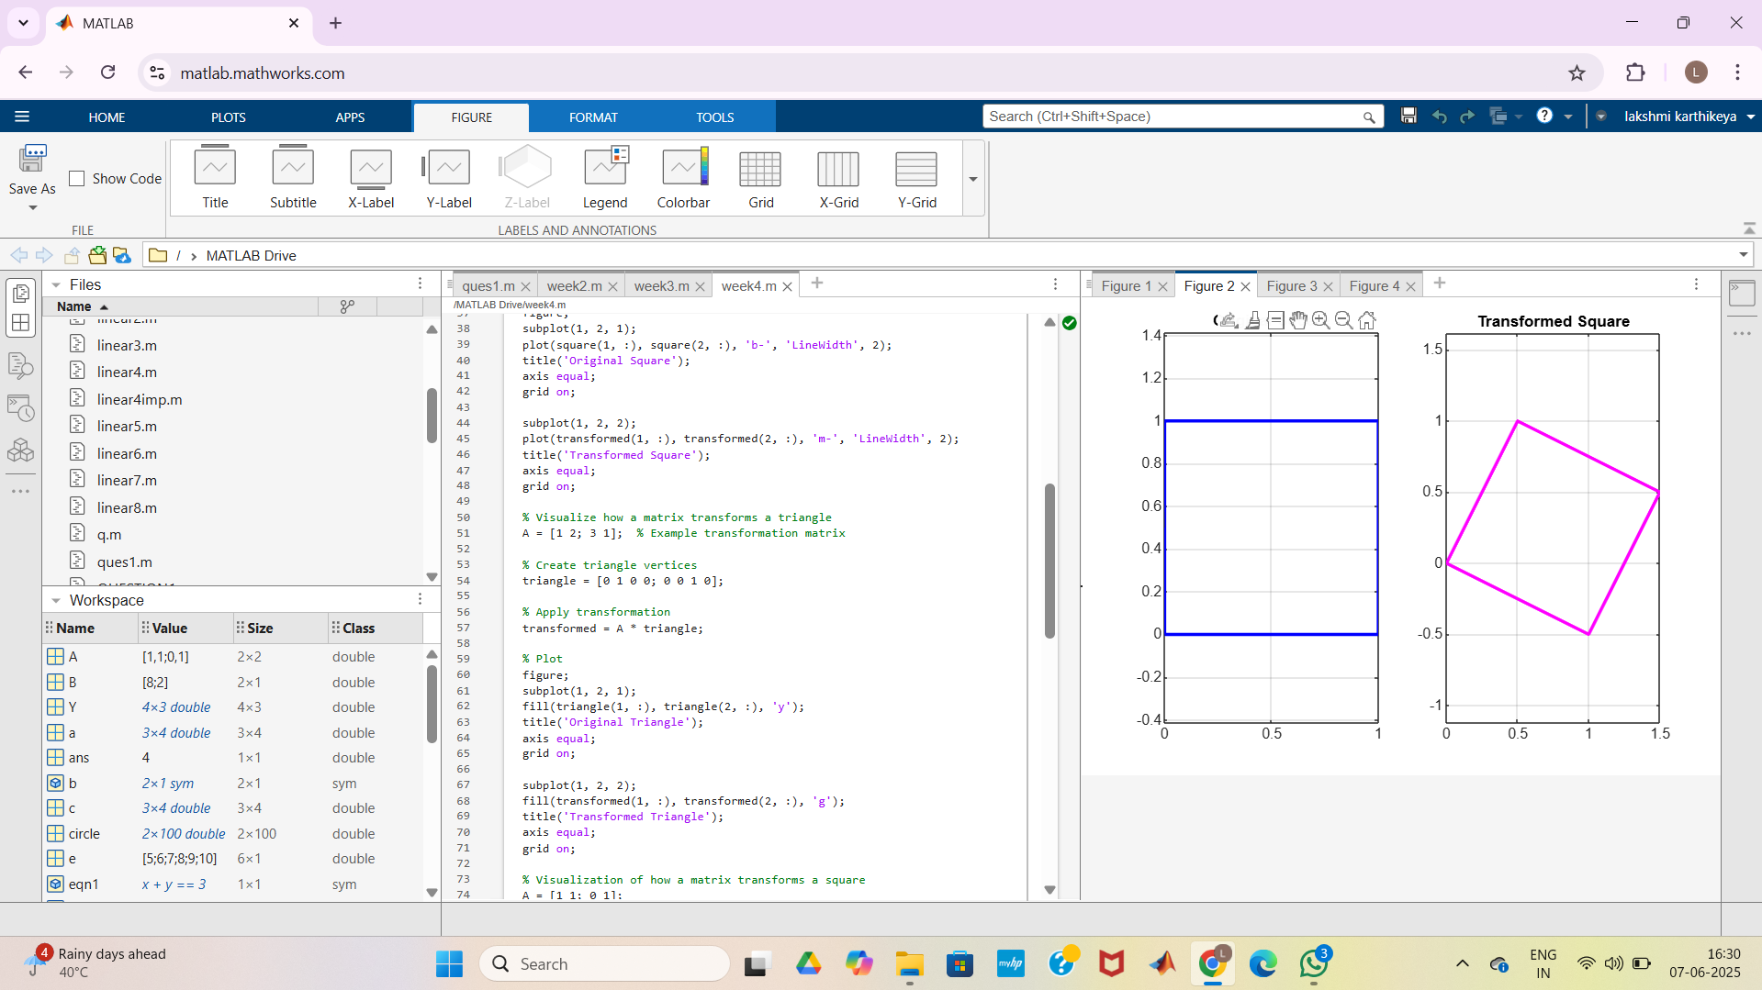

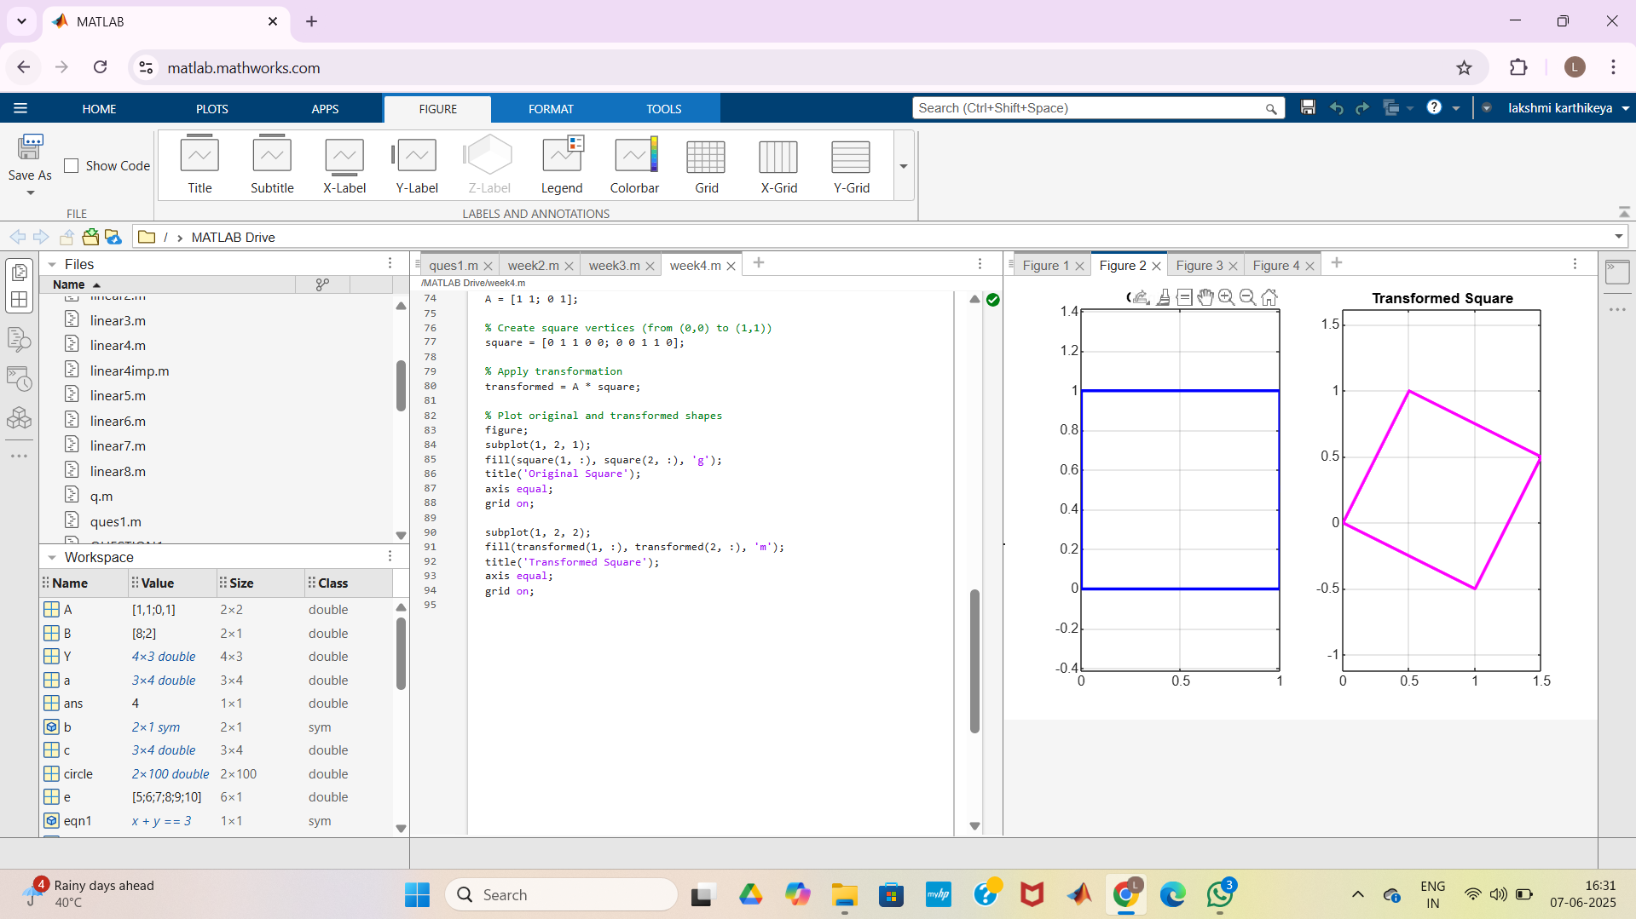

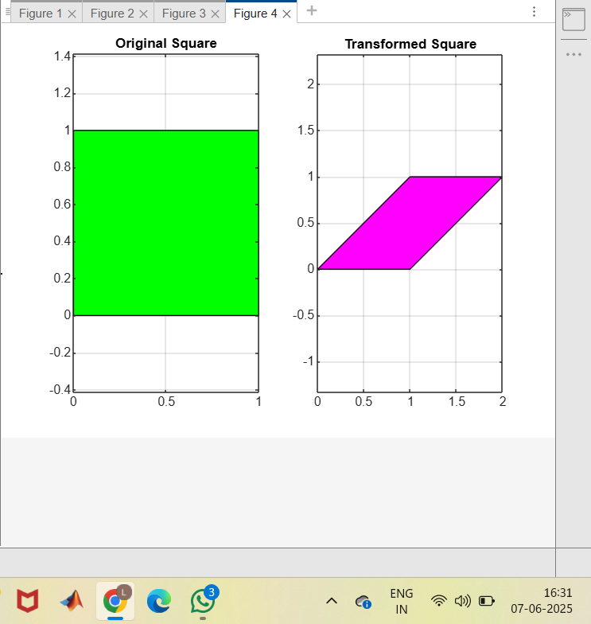

1. Using MATLAB, write a program to Visualize how a matrix transforms a triangle.

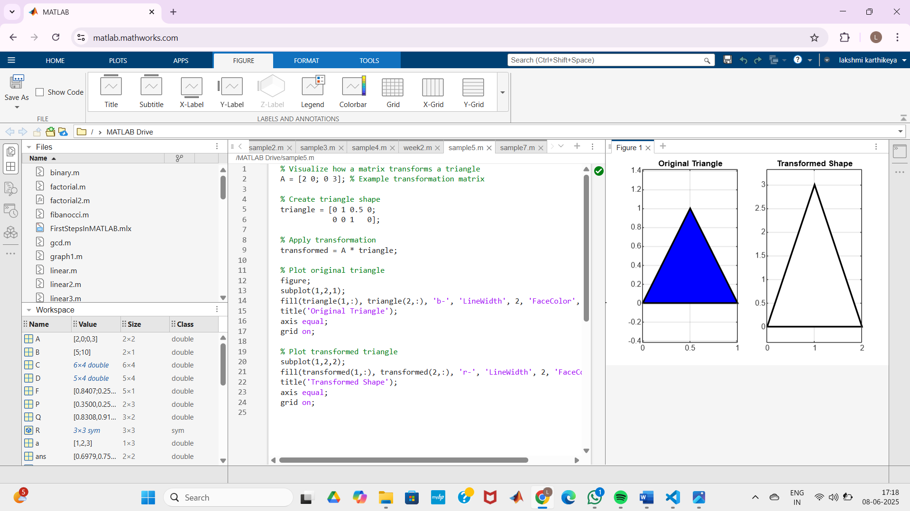

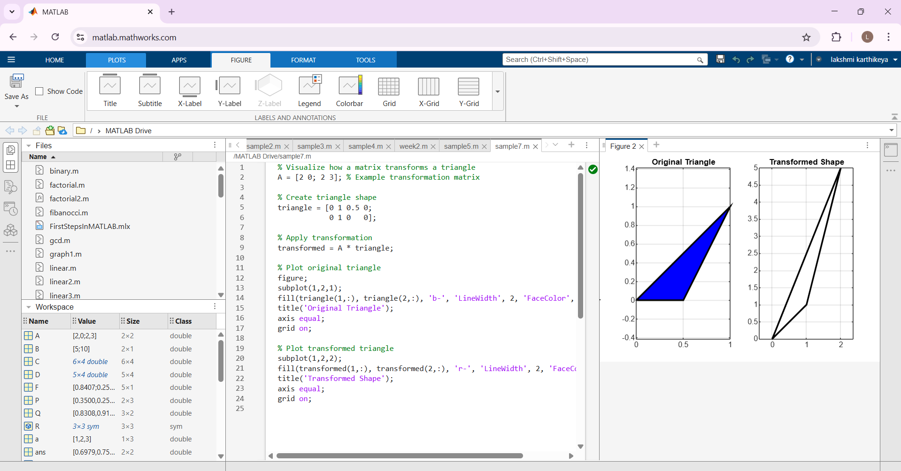

1. Using MATLAB, write a program to find diagonalisation of the matrix.

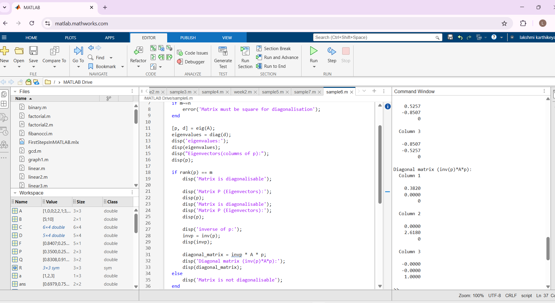

1. Using MATLAB, write a program to find orthogonal diagonalisation of a given matrix.

